[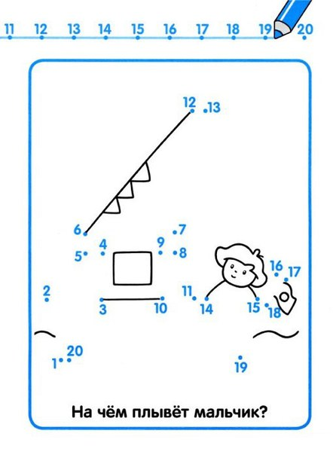](https://vk.com/photo-55615958_420874550)[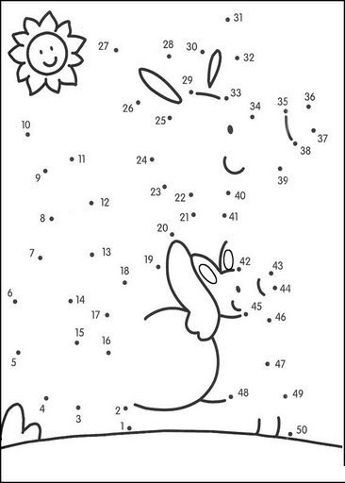](https://vk.com/photo-55615958_420874552)

[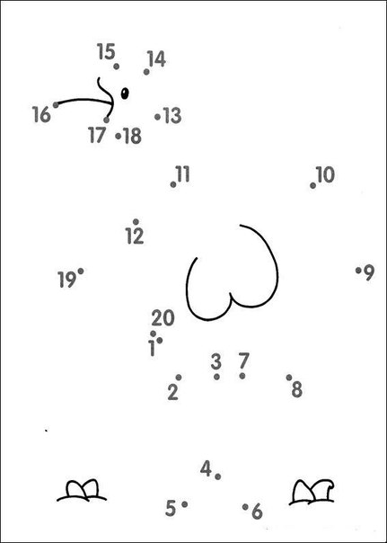](https://vk.com/photo-55615958_420874554)[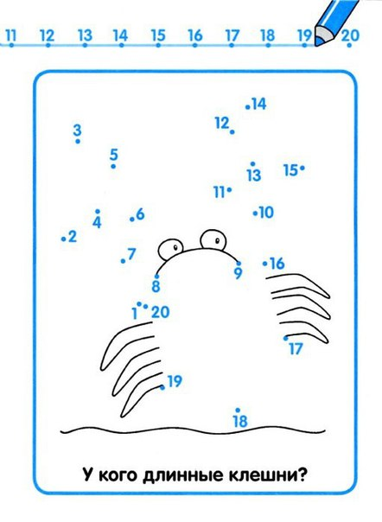](https://vk.com/photo-55615958_420874560)

[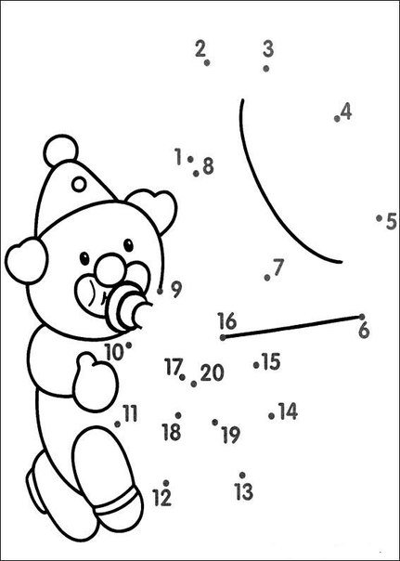](https://vk.com/photo-55615958_420874564)[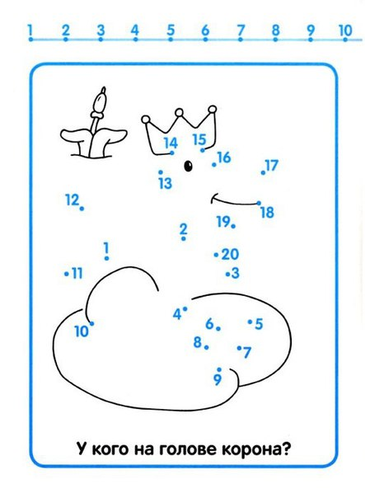](https://vk.com/photo-55615958_420874569)[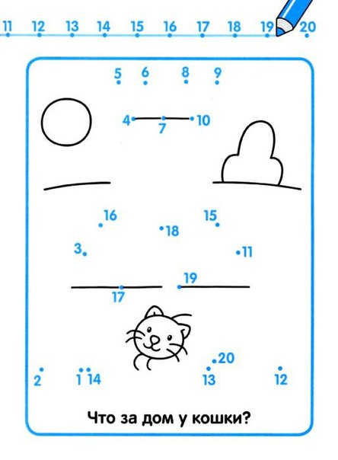](https://vk.com/photo-55615958_420874592)[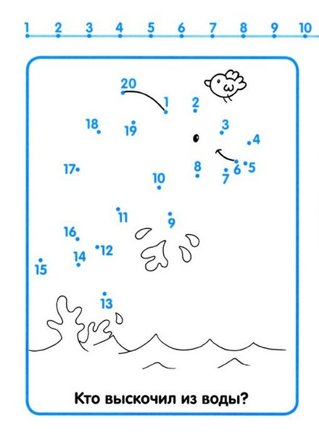](https://vk.com/photo-55615958_420874644)[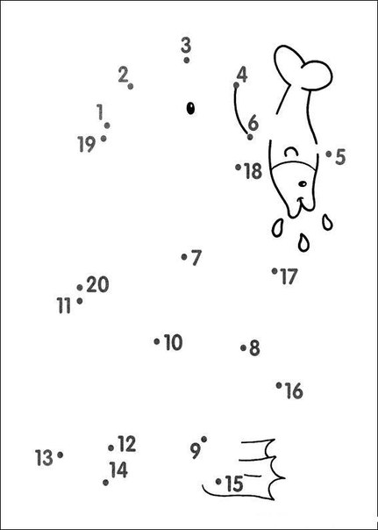](https://vk.com/photo-55615958_420874645)[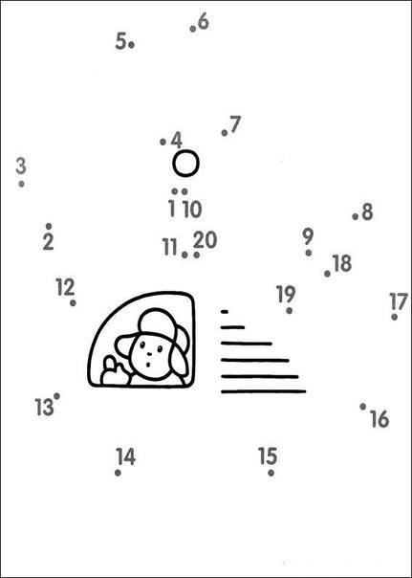](https://vk.com/photo-55615958_420874654)[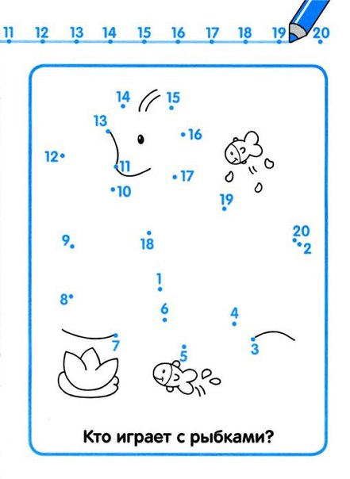](https://vk.com/photo-55615958_420874760)[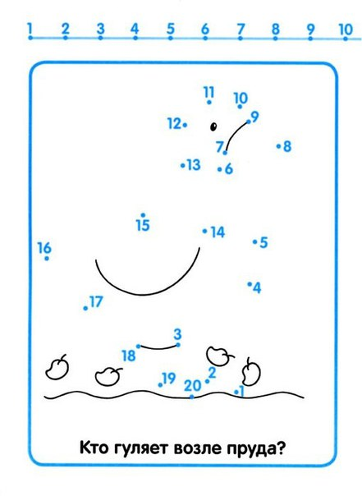](https://vk.com/photo-55615958_420874772)