[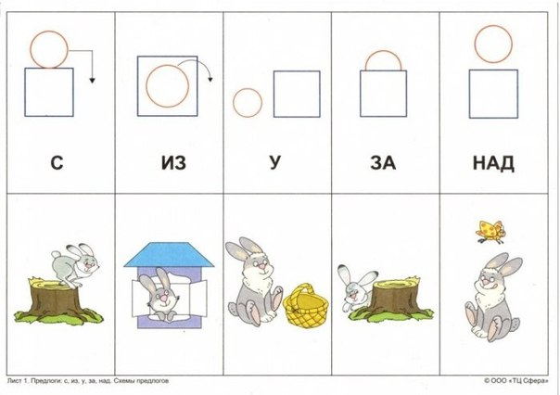](https://vk.com/photo-55615958_420119849)[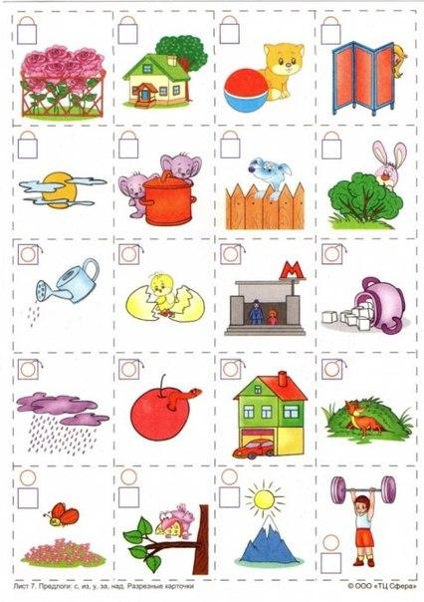](https://vk.com/photo-55615958_420119855)[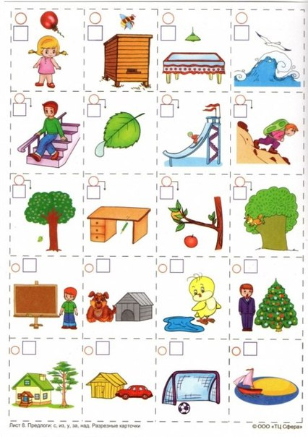](https://vk.com/photo-55615958_420119857)[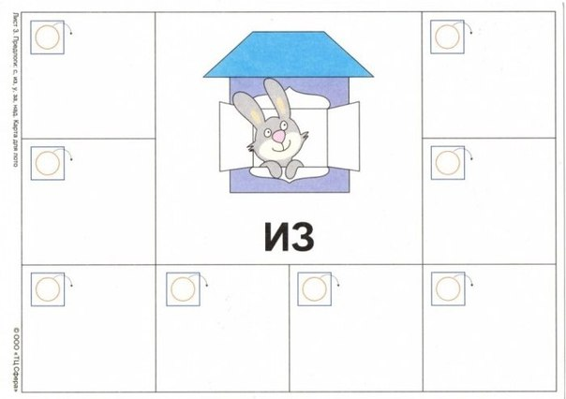](https://vk.com/photo-55615958_420119851)[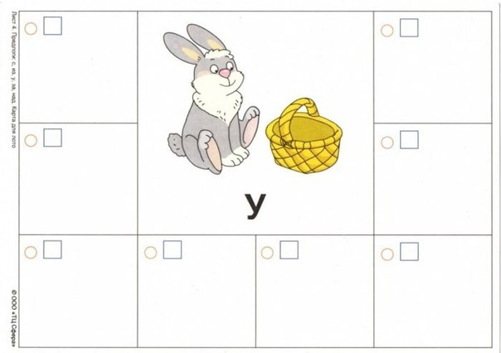](https://vk.com/photo-55615958_420119852)[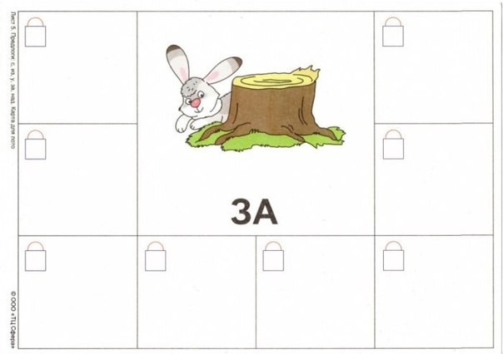](https://vk.com/photo-55615958_420119853)[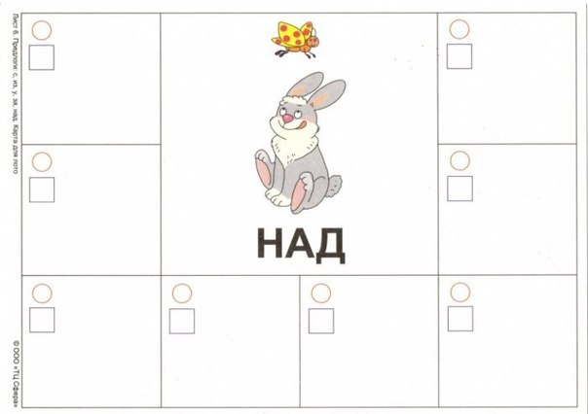](https://vk.com/photo-55615958_420119854)[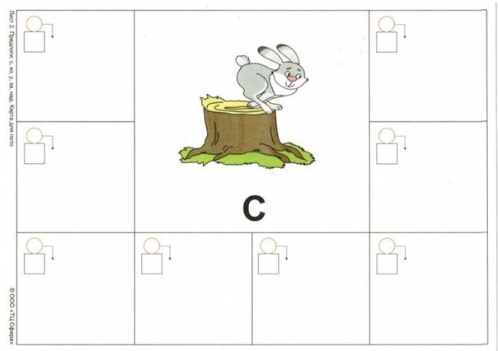](https://vk.com/photo-55615958_420119850)[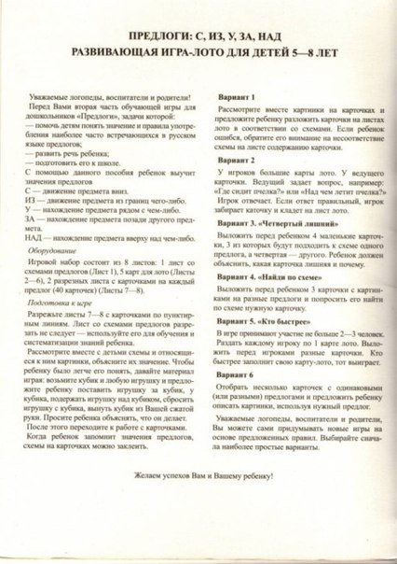](https://vk.com/photo-55615958_420119848)